## Soal

*Case*

**Bowling**

Below are some specifications you need to follow.

Project Structure

Your project should contain a main html file, several JavaScript files, assets, and the three.js library. You are to acquire three.js either from the three.js [official website](https://threejs.org/), [github repository](https://github.com/mrdoob/three.js/), or [CDN link](https://cdnjs.com/libraries/three.js).

You are required to include the following piece of code in your html file.

|  |
| --- |
| <style>  * { margin: 0; padding: 0; }  html, body { height: 100%; width: 100%; overflow: hidden; }  canvas { height: 100%; width: 100%; }  </style>  <script src="[Path to index.js file]" type="module"></script> |

You are free to split your code into several different JavaScript file, but code the main logic for creating the scene inside “index.js” file.

Renderer

|  |  |
| --- | --- |
| Property | Value |
| Type | WebGL Renderer |
| Antialiasing | Yes |
| Size | Window Size |

Camera

|  |  |
| --- | --- |
| Property | Value |
| Type | Perspective Camera |
| Field of View | 75 |
| Aspect Ratio | Window Ratio |
| Near Frustum | 0.1 |
| Far Frustum | 1000 |
| Position | Vector3 (20, 60, 180) |

Objects

* 1. Floor (Box Geometry)

|  |  |
| --- | --- |
| Property | Value |
| Material | Mesh Phong Material |
| Width | 250 |
| Height | 2 |
| Depth | 150 |
| Texture | floor.png |
| Position | Vector3 (35, -14, 35) |
| Rotation | Vector3 (0, -π/4, 0) |
| Receive shadow | Yes |

* 1. Pin

The pin will consist of upper, lower, neck, and head section. All sections will be assembled in Group. Note that the position and rotation of every section is relative to the Group.

* + 1. Upper (Cylinder Geometry)

|  |  |
| --- | --- |
| Property | Value |
| Material | Mesh Phong Material |
| Radius Top | 3 |
| Radius Bottom | 8 |
| Height | 20 |
| Radial Segments | 12 |
| Height Segments | 12 |
| Color | #FFFFFF |
| Position | Vector3 (0, 9, 0) |
| Cast shadow | Yes |

* + 1. Lower (Cylinder Geometry)

|  |  |
| --- | --- |
| Property | Value |
| Material | Mesh Phong Material |
| Radius Top | 8 |
| Radius Bottom | 5 |
| Height | 12 |
| Radial Segments | 12 |
| Height Segments | 12 |
| Color | #FFFFFF |
| Position | Vector3 (0, -7, 0) |
| Cast shadow | Yes |

* + 1. Neck (Cylinder Geometry)

|  |  |
| --- | --- |
| Property | Value |
| Material | Mesh Phong Material |
| Radius Top | 4 |
| Radius Bottom | 3 |
| Height | 12 |
| Radial Segments | 12 |
| Height Segments | 12 |
| Color | #FFFFFF |
| Position | Vector3 (0, 23, 0) |
| Cast shadow | Yes |

* + 1. Head (Sphere Geometry)

|  |  |
| --- | --- |
| Property | Value |
| Material | Mesh Phong Material |
| Radius | 4 |
| Width Segments | 32 |
| Height Segments | 16 |
| Color | #FF0000 |
| Position | Vector3 (0, 25, 0) |
| Cast shadow | Yes |

* 1. Ball (Sphere Geometry)

|  |  |
| --- | --- |
| Property | Value |
| Material | Mesh Phong Material |
| Radius | 10 |
| Width Segments | 32 |
| Height Segments | 16 |
| Texture | bowling-ball.png |
| Position | Vector3 (90, -3, 90) |
| Rotation | Vector3 (π/2, π/2, π/2) |
| Cast shadow | Yes |

Light

All lights in the scene will be able to **cast shadows**

* 1. Spotlight

|  |  |
| --- | --- |
| Property | Value |
| Color | #FFFFFF |
| Intensity | 1 |
| Position | Vector3 (100, 200, 300) |
| Shadow map width | 1024 |
| Shadow map height | 1024 |
| Shadow Camera Near | 0.5 |
| Shadow Camera Far | 500 |
| Cast Shadow | Yes |

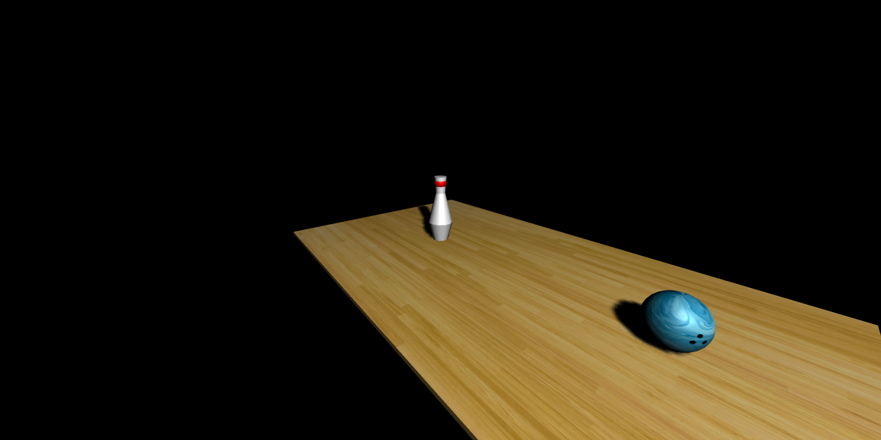

**Figure 1. Result**

***If there are any problems, please ask your assistant!***

**References:**

<https://stock.adobe.com/tr/contributor/207871140/mari-dein?asset_id=310746063>

https://denverdustless.com/maple-flooring-hard-enough-to-bowl-on/